
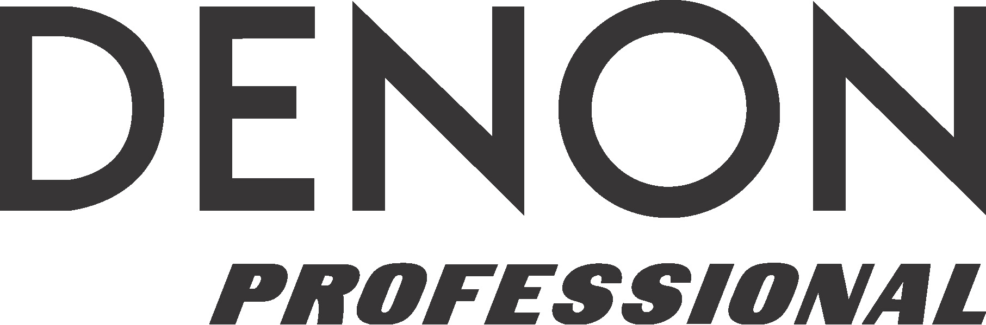

For Immediate Release

Contact: Neilson/Clyne, Inc.
Tel: (615) 662-1616
Fax: (615) 662-1636
info@neilsonclyne.com

DENON’S DN-V755 ASSURES THAT CITY COUNCIL
GETS THE WORD OUT WHEN NEEDED

— Junction City Council Chamber building has complete refit of information A/V system, with Denon DN-V755 Network A/V Player cost-effectively replacing cable and PC-based sources —

— Marantz PMD570 Solid State Recorder also installed as part of the
same new A/V system to record Council meetings —

NSCA EXPO, LAS VEGAS, NV, March 16, 2006 — Emergency news is critical in Kansas during tornado season, and this year residents of Junction City will be able to get their emergency warnings and other important municipal news in a much more timely manner, thanks to the inclusion of a Denon Professional DN-V755 Network A/V Player as part of a complete renovation of the city’s Council Chambers facility. The media systems retrofit, which was completed late last year, was designed and installed by Sound Solutions, the install division of SM Hanson, Inc. of Salina, Kansas, and also included a Marantz PMD570 rackmount Solid State Recorder that is now used to record all of the Council’s meetings.

For years, the Junction City municipal cable channel had relied on a PC running a PowerPoint® presentation outlining civil emergency procedures for the city and surrounding area cablecast on a signal from Cox Cable, which also supplied prerecorded background music. The system was fine for routine community affairs messages, but was cumbersome to update and activate in the event of an emergency, such as a tornado. “The Council wanted to be able to remotely activate and control the channel so it could be updated for situations like that,” says Aaron Johnson, Senior Systems Designer at Sound Solutions. “We installed the Denon DN-V755 as part of the overhaul of their entire A/V system specifically for this purpose, and it is the absolute best solution on the market for this. All of the PowerPoint slides were loaded into the Denon system, as well as a much wider array of music and other audio choices. Now, the system can be activated remotely by the City Manager, from home at 2 a.m., if necessary, via a secure, password-protected IP connection to the DN-V755. This way, the city is able to instantly run important messages and customize the sound that accompanies them. And with the DN-V755, it was able to accomplish this far more cost-effectively than they had with the previous arrangement, and the entire solution is contained in a single rack. These are advantages that only the DN-V755 could bring to this situation.”

The compact Denon Professional DN-V755 is indeed a single-system solution. It is remotely accessible via the web, has an internal 40 GB hard drive and provides system integrators with the solution they need to meet the increasing demand for digital signage multimedia solutions for theme parks, museums, houses of worship, kiosks, crisis management centers, retail environments and other commercial applications where high-quality, highly-reliable, customized video is desired.

…ends 413 words

About D&M Professional
D&M Professional, parent company of Denon Professional, Marantz Professional and Denon DJ, manufactures and distributes a reliable line of professional audio and video equipment for the broadcast, commercial, corporate, DJ, education, government, audio/visual, education, houses of worship, security, and related industries.
Visit D&M Professional at www.d-mpro.com or Denon DJ at: www.denondj.com.

About D&M Holdings Inc.
D&M Holdings Inc. (TSE II: 6735) is based in Tokyo and owns the Denon, Marantz, McIntosh Laboratory, Boston Acoustics, Snell Acoustics, D&M Professional, ReplayTV® and Escient® brands. Denon, Marantz, McIntosh and D&M Professional are global industry leaders in the specialist home theater, audio/video consumer electronics or professional audio markets, with a strong and long-standing heritage of manufacturing and marketing high-performance audio and video components. Boston Acoustics, with its signature The Boston Sound™, is a leader in premium loudspeakers for home and audio markets. Snell is a super premium speaker brand. The ReplayTV and Escient brands represent award-winning technologies in digital home entertainment. Additional information is available at www.dm-holdings.com.

# # #

D&M Professional, 1100 Maplewood Dr. Itasca, IL 60143
Phone: (630) 741-0330 Fax: (630) 741-0652

D&M Professional is exhibiting at Booth #2725 during the 2006 NSCA Expo in
Las Vegas, NV.

